IMPACT 2024 Sponsorship Package

IMPACT 2024, the premier conference for PCB and packaging professionals in Taiwan, organized by IEEE-EPS-Taipei, iMAPS-Taiwan, ITRI, and TPCA.This year's event will be held from Oct. 22nd-25th at Taipei Nangang Exhibition Center, in conjunction with TPCA Show 2024. With a central theme of “IMPACT on Sustainable Technology", the symposium will explore the latest electronic technologies while fostering collaboration among enterprises and organizations.
As artificial intelligence, quantum computing, and low-earth orbit satellite communications rapidly advance, the convergence of technology and resource sustainability becomes an increasingly urgent strategic imperative. IMPACT 2024 will delve deep into these technological innovations and sustainability advancements in PCB and packaging. The conference will offer a wide range of activities including professional development courses, plenary speeches, special sessions, industrial sessions, invited talks, outstanding papers, and poster presentations.
Moreover, this conference will collaborate with esteemed international organizations such as ICEP and JIEP from Japan, iNEMI, iMAPS, and IEEE EPS from the USA, along with prominent global consulting companies like Yole Développement and Techsearch from the USA.
As a sponsor, your company will enjoy exclusive access to cutting-edge research and the opportunity to showcase your innovative products and solutions to key decision-makers. Additional benefits include company promotion, recruitment opportunities, and the chance to elevate your company's reputation. We cordially invite you to join us as a valued supporter.

Sincerely,

Dr. S. L. Fu
Chair of IMPACT 2024
Chairman, IEEE EPS-Taipei

【IMPACT 2024】

【Date】Oct. 22nd (Tue.)-25th (Fri),2024 【Venue】Taipei Nangang Exhibition Center
【Theme】IMPACT on Sustainable Technology
【Exhibition】TPCA Show, TAITRONICS, OPTO TAIWAN, AIoT Taiwan
【Official Website】www.impact.org.tw

【Sponsorship Package】 ★Exclusively

Sponsorship | Industrial /Special Forum | Golden | Silver | Bronze | Table  Show  ★ | Outstanding Paper Award  ★ | Badge  ★ | Gift proposed by Company ★
$ (K NTD) | 200 | 120 | 90 | 60 | 120 | 150 | 60 | 180
Free Registration | 20+Invited | 12 | 9 | 6 | 4 | 4 | 4 | 4
The logo will be included on all promotional materials | V | V | V | V | V | V | V | V
logo will be listed on sponsored forum/Exclusive EDM | V | X | X | X | X | X | X | X
Logo listed on Paper Award ceremony | X | X | X | X | X | V | X | X
Advertising printed in Proceedings | 1 Page | 1 Page | ½  Page | X | X | X | X | X
Digital posters/Corporate Video | V | V | V | V | V | V | V | V
Provide an IBM table | X | X | X | X | V | X | X | X
LOGO listed on pen | X | V | X | X | X | X | X | X
LOGO listed on gift | X | X | X | X | X | X | V | V
Extra registrations | $30,000: 5 registrations ;$50,000:10 registrations

IMPACT 2024 Agenda (TBD)
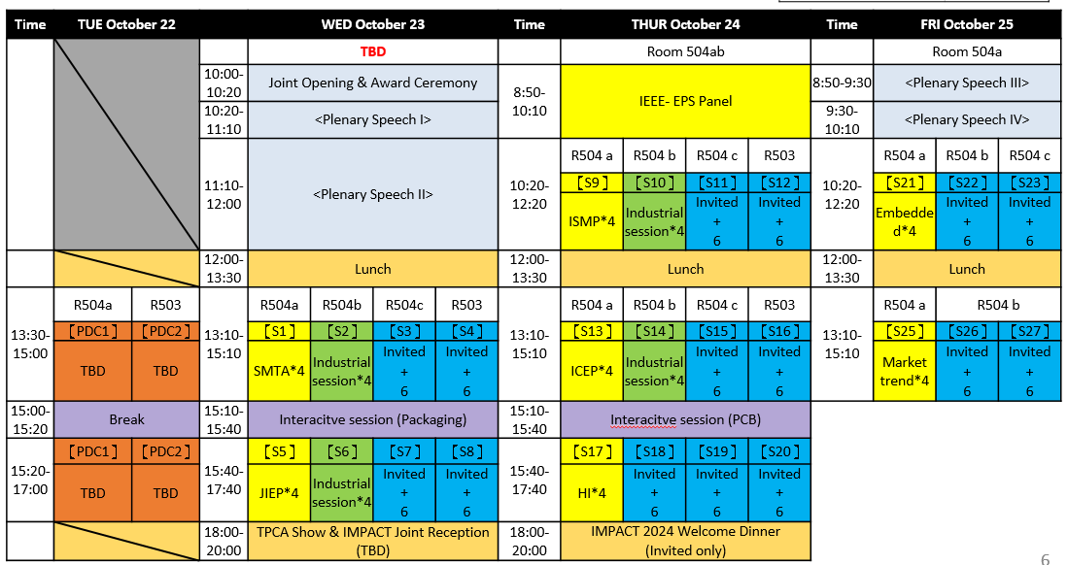

Sponsorship Package
Company Profile
Company Name
Contact Person |  |  | Job Title
Phone/ext. |  |  | Fax
E-Mail |  |  | Business No
Address |  |  | Webpage
Company Logo | Please email your Logo to service@impact.org.tw
Honored Advisor as a representative in IMPACT 2024 |  | Name
 |  | Job Title
 |  | E-Mail

SPONSORSHIP：Please your preferred sponsorship
Sponsorship | Sponsor Fee  (K NTD) | Free Registrants
Industrial Forum | - $200 | 20+Invited Speakers
Special Forum；Topic: | - $200 | 20+Invited Speakers
Gold | - $ 120 | 12
Silver | - $ 90 | 9
Bronze | - $ 60 | 6
Table Show (Exclusively) | - $120 | 4
Badge (Exclusively) | - $60 | 4
Outstanding Paper Award (Exclusively) | - $ 150 | 8
Gift proposed by Sponsor | - $ 180 | 4
Extra Registrations | - $ 30 | 5
 | - $ 50 | 10

Payment details

Account Name | Taiwan Printed Circuit Association | Secretariat Address | No 147, Sec 2, Gaotie N Rd, Dayuan, Taoyuan 33743, Taiwan
Swift Code | LBOTTWTP013 | Account Number  (A/C No) | 131-001-00069-9
Bank No/ABA No | 122042564
Bank Name | Land Bank of Taiwan (Taoyuan Branch) | Bank Address | No. 75, ChungCheng Rd., Taoyuan 330, Taiwan

IMPACT Reference

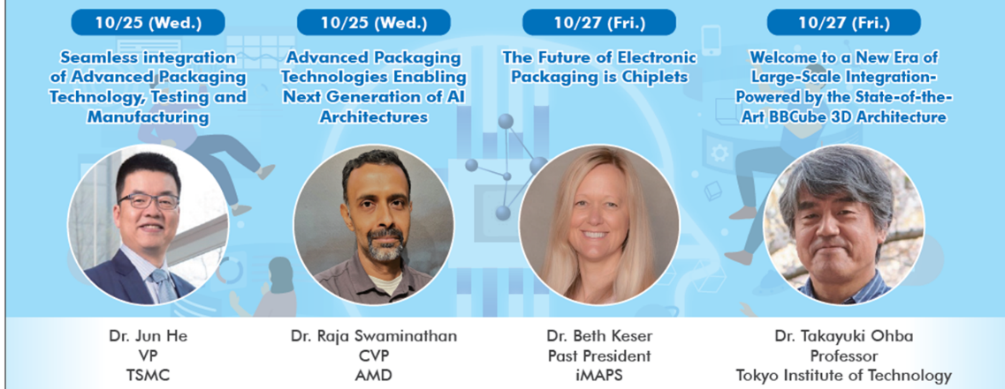
IMPACT 2023 Plenary Speakers

Paper statistics
Year | 2023 | 2022 | 2021
Poster | 48(P25,B23) | 37(P23,B14) | 37(P-25,B-12)
Oral | 86 | 82 | 70
Invited | 73 | 37 | 46
Industrial | 19 | 33 | 19
Plenary | 4 | 5 | 5
Total | 230 | 194 | 177

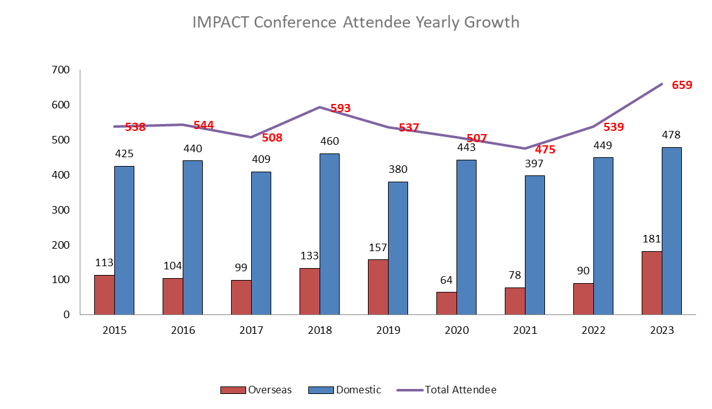
Conference Attendee statistics

