Guidelines for Preparing a Contribution to 2023Annual Conference of Taiwanese Society of Biomedical Engineering (TSBME 2023)-Annual Report of Ministry of Science and Technology, Taiwan (14-point, Times New Roman, Boldface, Center)
A.B. Chao¹, C. Chien² and Shu-Ping Lin^{1,*} (12-point, Times New Roman, Center, further asterisk for correspondence author)
¹ Department, Institution, City, Country
² Department, Institution, City, Country
* Corresponding Email:

ABSTRACT (10-point, Times New Roman, boldface, centered)
This is a sample template to demonstrate the preparation guidelines for the papers to be published in the proceedings of the 2023 Annual Conference of Taiwanese Society of Biomedical Engineering (TSBME 2023)-Annual Report of Ministry of Science and Technology, Taiwan. The conference will be held at Chen Chih Hall at Chung Yuan Christian University, Taoyuan, Taiwan on November 11 and 12, 2023. Please refer to the official website of TSBME 2023 for the updated news and submission deadline. (https://tsbme2023.conf.tw/) You are welcome to use this template to prepare your papers. (10-point, Times New Roman)
Keywords: paper, guidelines, national conference. (2~4 words, 10-pt, Times New Roman)
- INTRODUCTION
Please submit clearly printed two-page camera-ready paper in electronic forms in the on-line submission system. The URL link of the official website of TSBME2023 is (https://tsbme2023.conf.tw/). Please upload only PDF file to submission website. Other formats, such as LaTex, AmiPro…etc., will NOT be accepted.
- FORMAT
Set the size of the paper to the standard A4 size with 30-mm margins for top and bottom and 20-mm margins for right and left. Use a two-column format for the text. The columns should be separated by 6 mm (0.24 inch). The bolder for the paper format is fixed. Please do not change this bolder setting.
The required typeface is Times New Roman. The title should be in boldface letters centered across the top of the first page using 14-point font. The name(s) and affiliation(s) of the author(s) should be centered below the title in 12-point font. Add upper-case asterisk for corresponding author. The paper begins with the abstract and keywords followed by the main text. Required type size for text, figure captions, references, and within all figures is 10-point.
- Headings
Major headings should be centered, 10-point boldface. Subheadings should appear on a separate line with initial capitals using 10-point boldface.
- References
List of references with detailed information should be placed at the end of the paper. When referring to them in the text, type the corresponding reference number in square brackets, as in this example [1]. References should be listed in the order they were introduced in the article and the reference should follow the format at the end of this template [2].
- Equations
Equations should be centered and use Times New Roman and Symbol fonts. If more than one equation are used, number them on the right, as in Eq. (1),
(1)
- Figures, and tables
Figures and tables should be placed after the references, or be embedded in the text, but avoid breaking up the text into small block. The larger charts can span two columns. Figure captions should be placed below the figures. Table captions should be centered above the tables. The font for captions is 10-point. The resolution of scanned pictures and photos needs to be 300 dpi or equivalent.
- miscellaneous items
Please upload the electronic files in the website of (https://tsbme2023.conf.tw/). The decision of the review will be notified by email. You can also have the latest information about the submission from the website. If you have any question, please contact us by email: andrewchien@ethinkpco.com.tw。
Each paper requires at least one author to register for payment. A registered applicant can only report up to two papers.
In order to meet the needs of the funding agency, please sign the “Power of Attorney for Presentation Materials” on page 3.
- ACKNOWLEDGMENTS
If the paper is supported by the Ministry of Science and Technology in Taiwan, please write project number in the acknowledgement section.
- REFERENCES
- H. J. Sheen, W. J. Chen, and J. S. Wu, "Flow patterns for an annular flow over an axisymmetric sudden expansion," Journal of Fluid Mechanics, vol. 350, pp. 177-188, 1997.
- F. K. Forster and R. L. Bardell, "Design, Fabrication and Testing of Fixed-Valve Micropumps," ASME, vol. 234, pp. 39-44, 1995.
- C. W. Fitko and A. Ravve, Structure Analysis, U. S. Pat., 3374723, 1967.
- http://mech.stust.edu.tw/sysid/mech/NMC2014/Welcome.htm
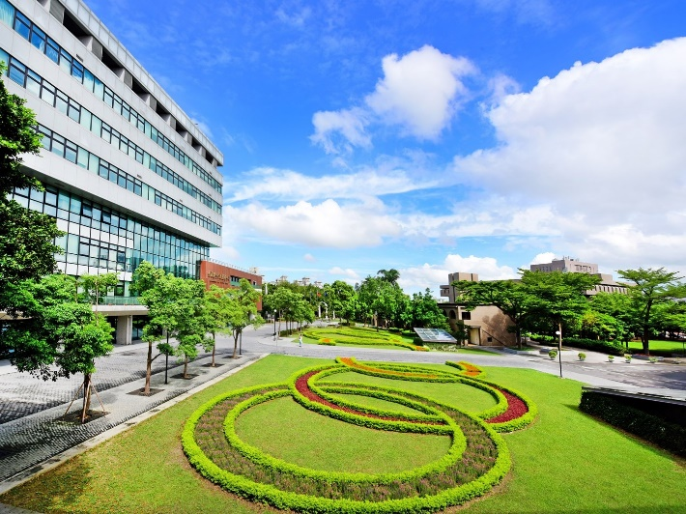
Figure 1. xxxxx

Table 1 yyyyyyy

