Template for two-page summary
for the Oral Presentation Award
Annual Meeting of Physics, TPS, 2026

AuthorA¹, AuthorB², and AuthorC^{3*}
¹Affiliation, City, Country
²Affiliation, City, Country
³Affiliation, City, Country
*email of Corresponding author: xxx@xxxx.xxxx.

Abstract: The abstract is limited to 200 words and cannot contain equations, figures, tables, or references. It should concisely state what was done, how it was done, the principal results, and their significance.

Keywords: (at least one keyword) Atom-Molecular Optical Physics, Quantum Optics.

1. Introduction

The total paper length must be two (2) pages. No extra pages are permitted—text (size 10, standard).

Prepare your technical paper in single-spaced, single-column format on A4 paper sheet (210×297 mm). Set top and bottom margins to 25.4. mm and left and right margins to 20 mm. Paragraph indentation is 4 mm. Please justify text on both sides. Use one blank line between sections and between text and tables or figures. Adjust the length of the text on the last page to balance the layout.

2. Technical Work

A primary section heading is enumerated by a Roman numeral followed by a period and is centered above the text. A primary header should be in small caps. The first letter of each significant word is capitalized.

Do not number Appendix, Acknowledgment, and References.

A secondary section heading is enumerated by a capital letter followed by a period and is flush left above the section. The first letter of each significant word is capitalized, and the heading is italicized.

Figures and Tables

In labeling figure axes, please use words rather than symbols. Put units in parentheses, as in Fig. 1.

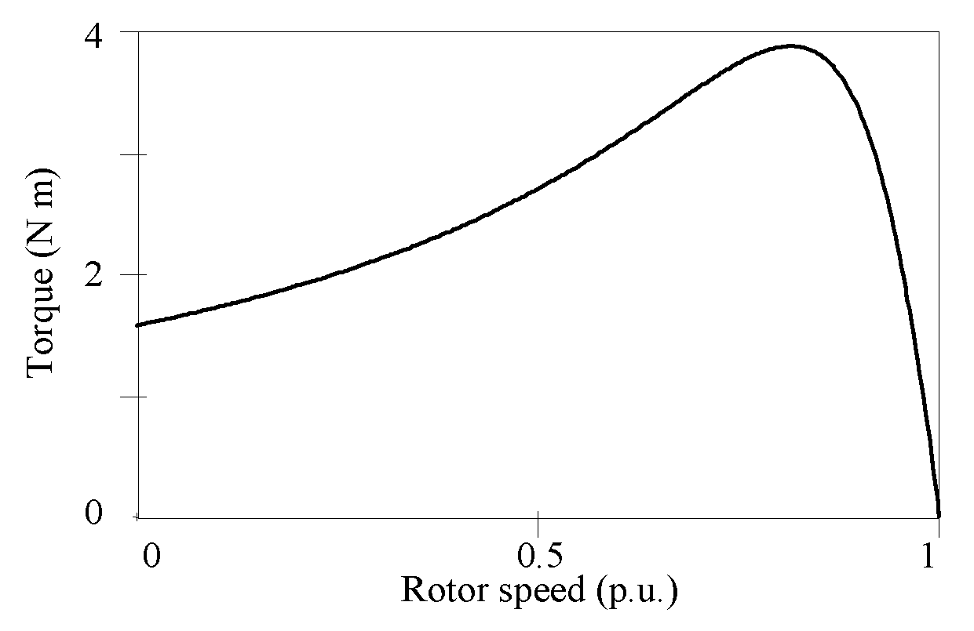
Fig. 1. Torque-speed characteristic of a three-phase induction motor.

Figures and tables must fit within the page margins and should not extend beyond them. Figure captions should appear below the figures, and table captions should appear above the tables..

Abbreviations and Acronyms

Define less common abbreviations and acronyms the first time they appear in the text, even if they have been defined in the abstract. Use abbreviations in the title only if absolutely necessary.

Math and Equations

Use the Microsoft Equation Editor or the MathType commercial add-on for MS Word create all mathematical expressions. Number equations consecutively with numbers in parentheses aligned to the right margin, as in (1).
Ensure the symbols in your equation have been defined before the equation appears or immediately afterward.
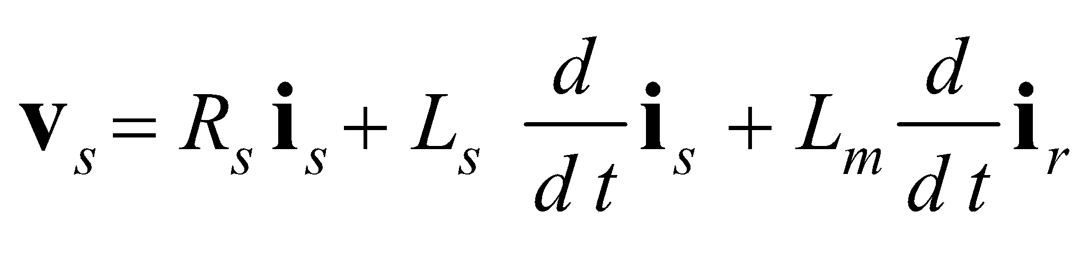 (1)
where R_{s} is the stator phase resistance.

Use the International System of Units (SI - MKSA) as primary units. British units may be used as secondary units in parentheses if necessary.

3. Conclusions

Conclusions are one of the most important parts of a paper. Please give careful consideration to this section. Authors may then proceed to the submission site to upload their paper once all requirements have been completed.

References

- J. Clerk Maxwell, A Treatise on Electricity and Magnetism, 3rd ed., vol. 2. Oxford: Clarendon, 1892, pp. 68-73.
- A. K. Ekert, “Quantum cryptography based on Bell’s theorem,” Phys. Rev. Lett. 67, 661 (1991).
- A. B. CCC, D. E. FFF, and G. HHH “Title of paper if known,” unpublished.

